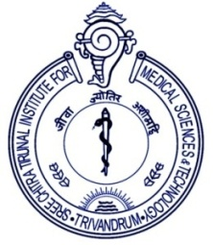 | श्री चित्रा तिरुनाल आयुर्विज्ञान और प्रौद्योगिकी संस्थान, त्रिवेंद्रम , केरल– 695 011  (एक राष्ट्रीय महत्व का संस्थान, विज्ञान एवं प्रौद्योगिकी विभाग, भारत सरकार)  SREE CHITRA TIRUNAL INSTITUTE FOR MEDICAL SCIENCES AND TECHNOLOGY, THIRUVANANTHAPURAM, KERALA – 695 011  (An Institution of National Importance, Department of Science and Technology, Govt. of India)  टेलीफॉन नं.Telephone No. 0471- 2443152 /2443085/Fax- 0471- 2446433/2550728  ई-मेल/E-mail : director@sctimst.ac.in वेबसाइट/ Website : www.sctimst.ac.in
Annexure – I
Approval for Purchase of goods/services
1. | Name of the Department
2. | Indent Number and Date
3. | Item Description
4. | Quantity
5. | Total Value of the Indent
6. | Reason for not procuring through GeM

Undertaking:
It is undertaken that:

I have not mentioned any make/model or accessories leading to prioritization of a particular make/model in the name of the indented item(s) and its specifications except in case of proprietary item(s).

Signature of the Indenter | Signature of HoD

Signature of the Nodal Officer | Signature of the Verifying Officer

To : The Purchase Department, Hospital Wing/BMT Wing, SCTIMST.

